Guidelines for for services and waste types of our website

Functionalities:

1. Waste Categorization Guide – This interactive page demonstrates how to distinguish between hazardous, recyclable, non-hazardous, and biodegradable waste.
2. Redeemable Rewards – Users can trade points for goods, deals, or donations in this rewards catalog.
3. Waste Usage Tracker – Provides an overview of the waste habits of users and lets them enter the sorts of waste they produce on a daily or monthly basis.
4. User Profile Management – For quicker booking, keep track of addresses, preferences, and past transactions.
5. Educational Blog/Articles Section – Content that is updated frequently on laws, community initiatives, and best practices.

Type of waste

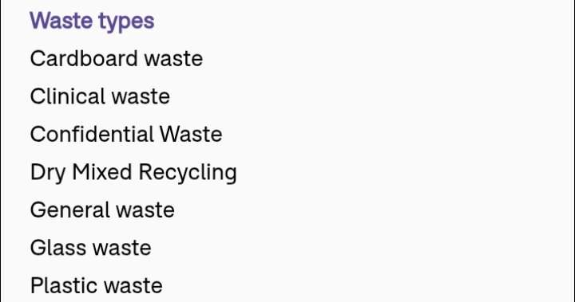

Services we offer:

1. Waste Collection
2. Waste Consultant
3. Waste Management
4. Waste Audit
5. Waste Management plan
6. Waste Disposal
7. Commercial Recycling
8. Recycling Rebates
9. Business Waste Collection